Asia-China-Hongshan-Jade-Cong

NK5750.2.A1

H: 5.8 cm. x W: 3.4 cm.

Material: Jade

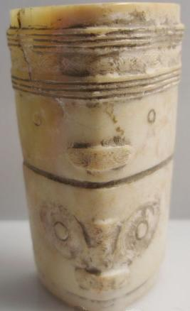 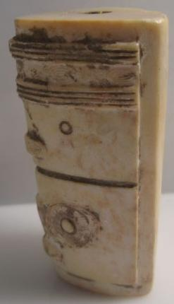 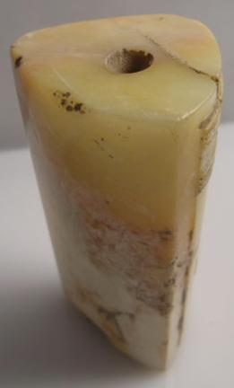 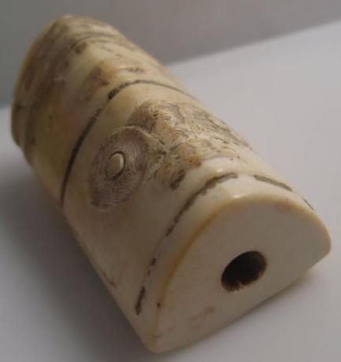

This Hongshan jade cong has two different masks depicting deceased ancestors. While it is diminutive in size this feature distinguishes it as being significant.

